Thomas Jubb

MMA Companion
Computer Science NEA

Contents
Features included in the prototype 2
Features not included in the prototype 3
Prototype 4
Evaluation of current system 5
Shortcomings and improvements 6

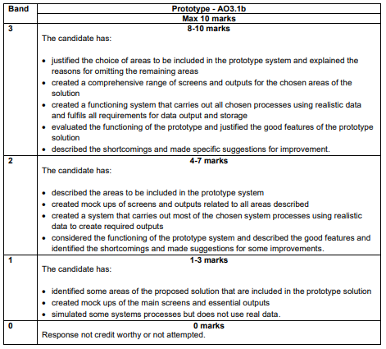
This is for your reference only and needs to be deleted when it is handed in as a final copy.

Please also delete any of my comments from the sections below, on final hand in

Justification of features

Prototype

Include print screens of every screen of your system you will be including in the prototype. This should be in a logical order, generally how the user would see them. Make sure you show these with realistic data and any error messages/validation this will generate.

Evaluation of current system
Evaluate your system, you should have completed enough of the user requirements to evaluate against these. Justify the good features of your system, highlighting these (brag a little)

Shortcomings and improvements

Explain the shortcomings and limitations or that you have identified in general about your current system. For each of these you must have specific suggestions for improvements.

